

Data Science Project
Waleed Afzal: 23P-0566
Shawaiz Shahid: 23P-0599
Topics: EDA, Model training, Regression, K-
fold CV, Bootstrapping
Submitted to : Ma’am Dr. Rabia Maqsood
Date: 2/Dec/2025

Code: The code file with the name (ProjectCode.ipynb) is attached in the zip folder that was submitted.
Streamlit Dashboard App: The streamlit app is created as the app.py file and the outputs are as follows:
Pipeline Flow Diagram of the Project 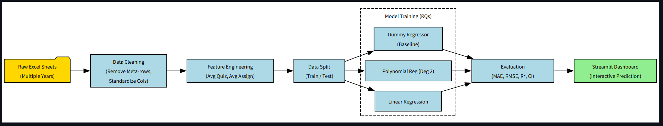
First Page of the App:
Pipeline & Workflow
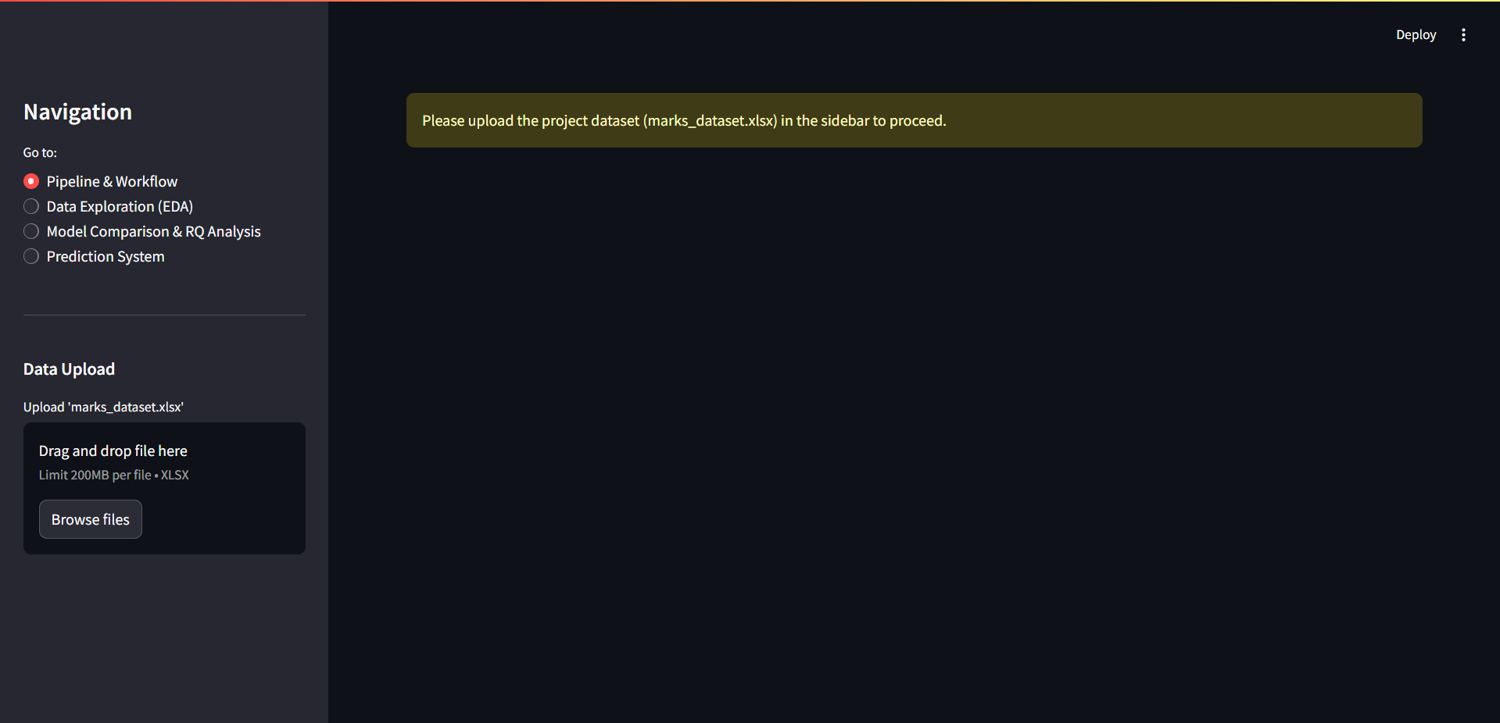
After uploading the dataset file, the page will show the project workflow diagram
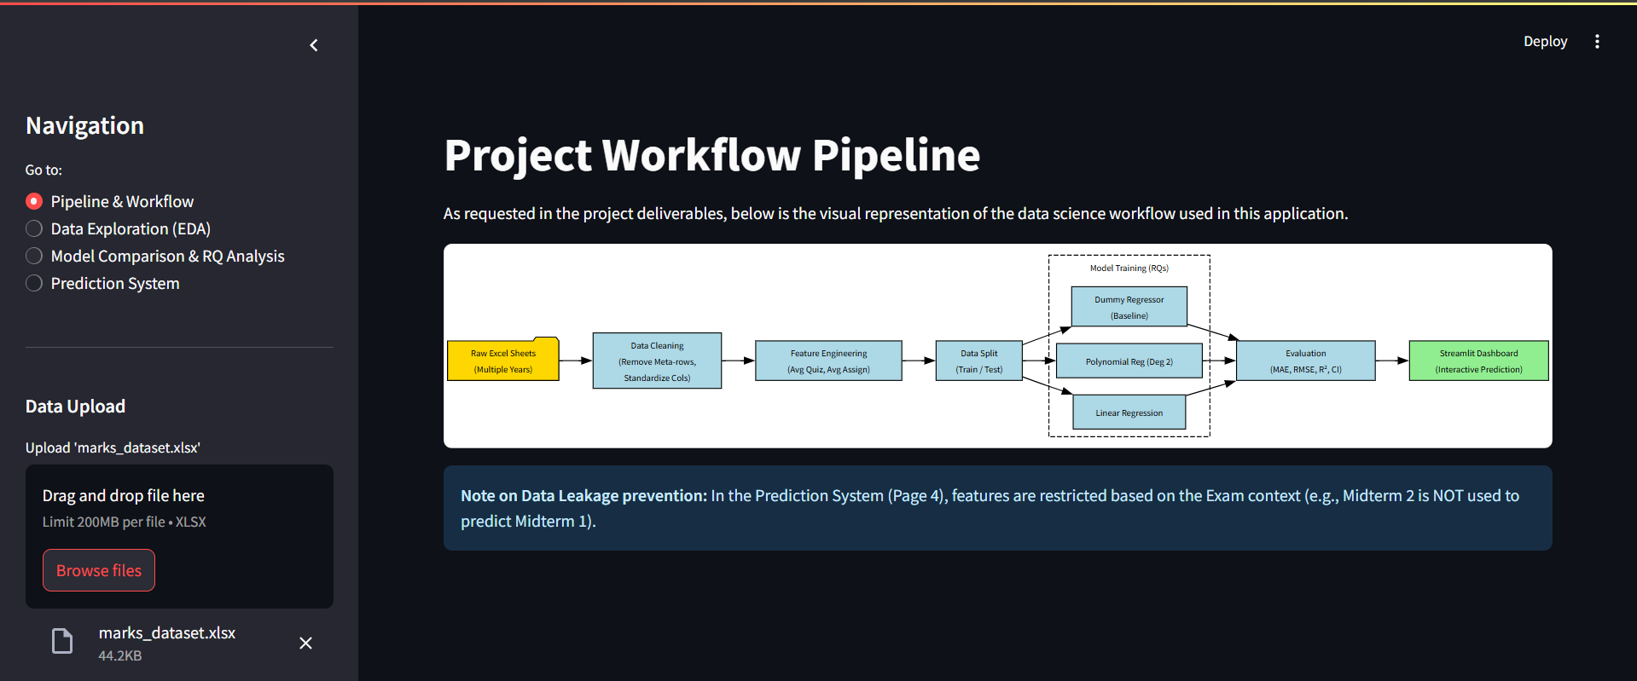
Second Page of the App:
Data Exploration(EDA)
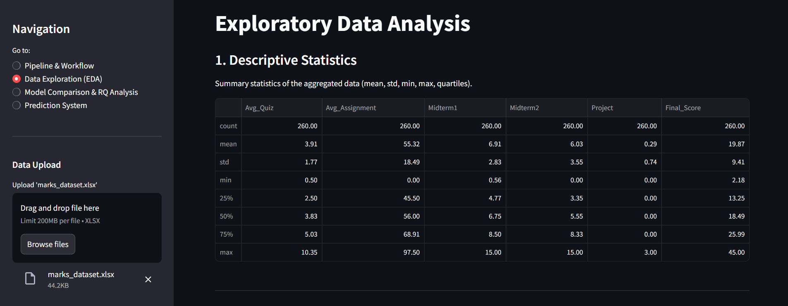
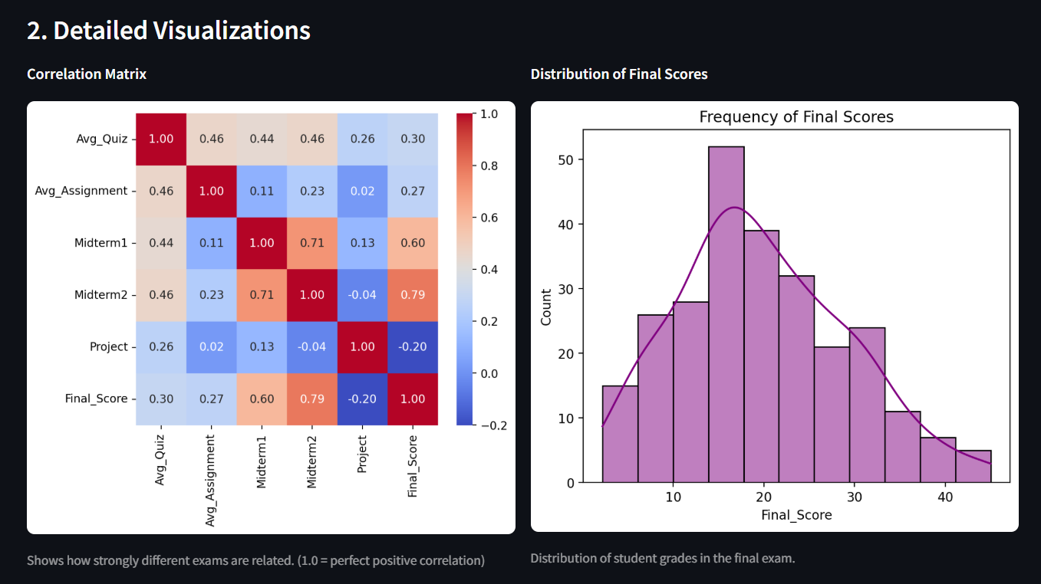
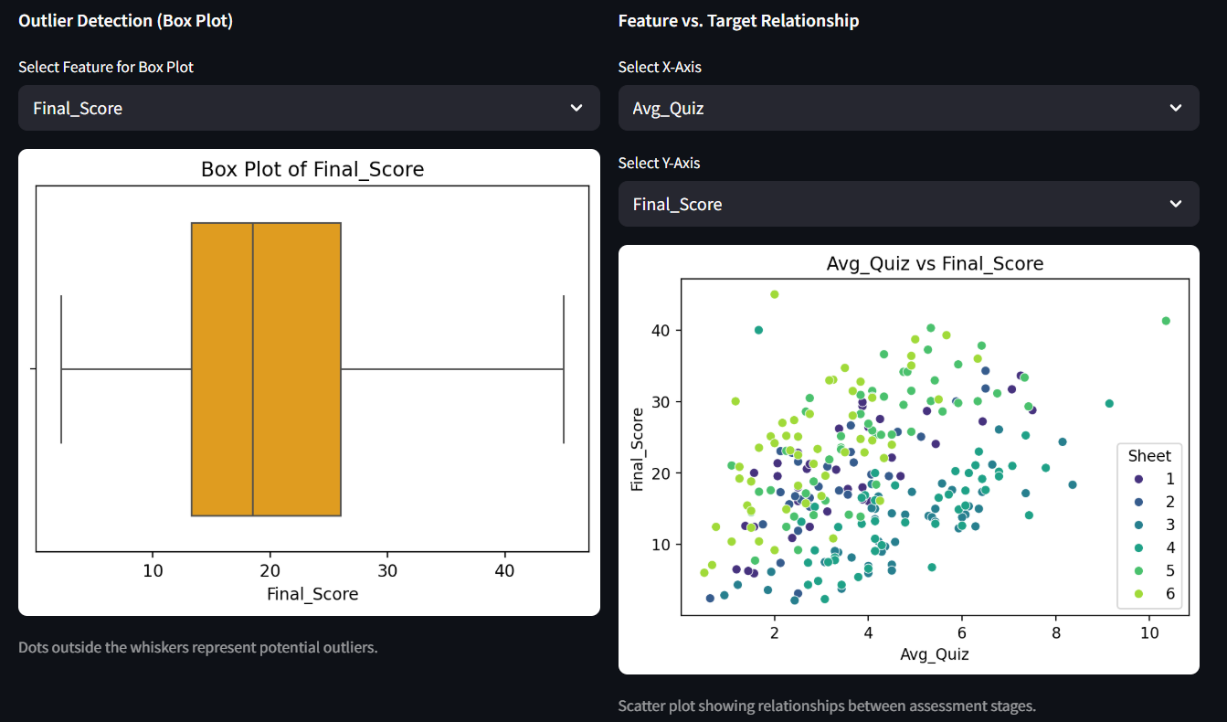
Third Page of the App:
Model Comparison & RQ Analysis

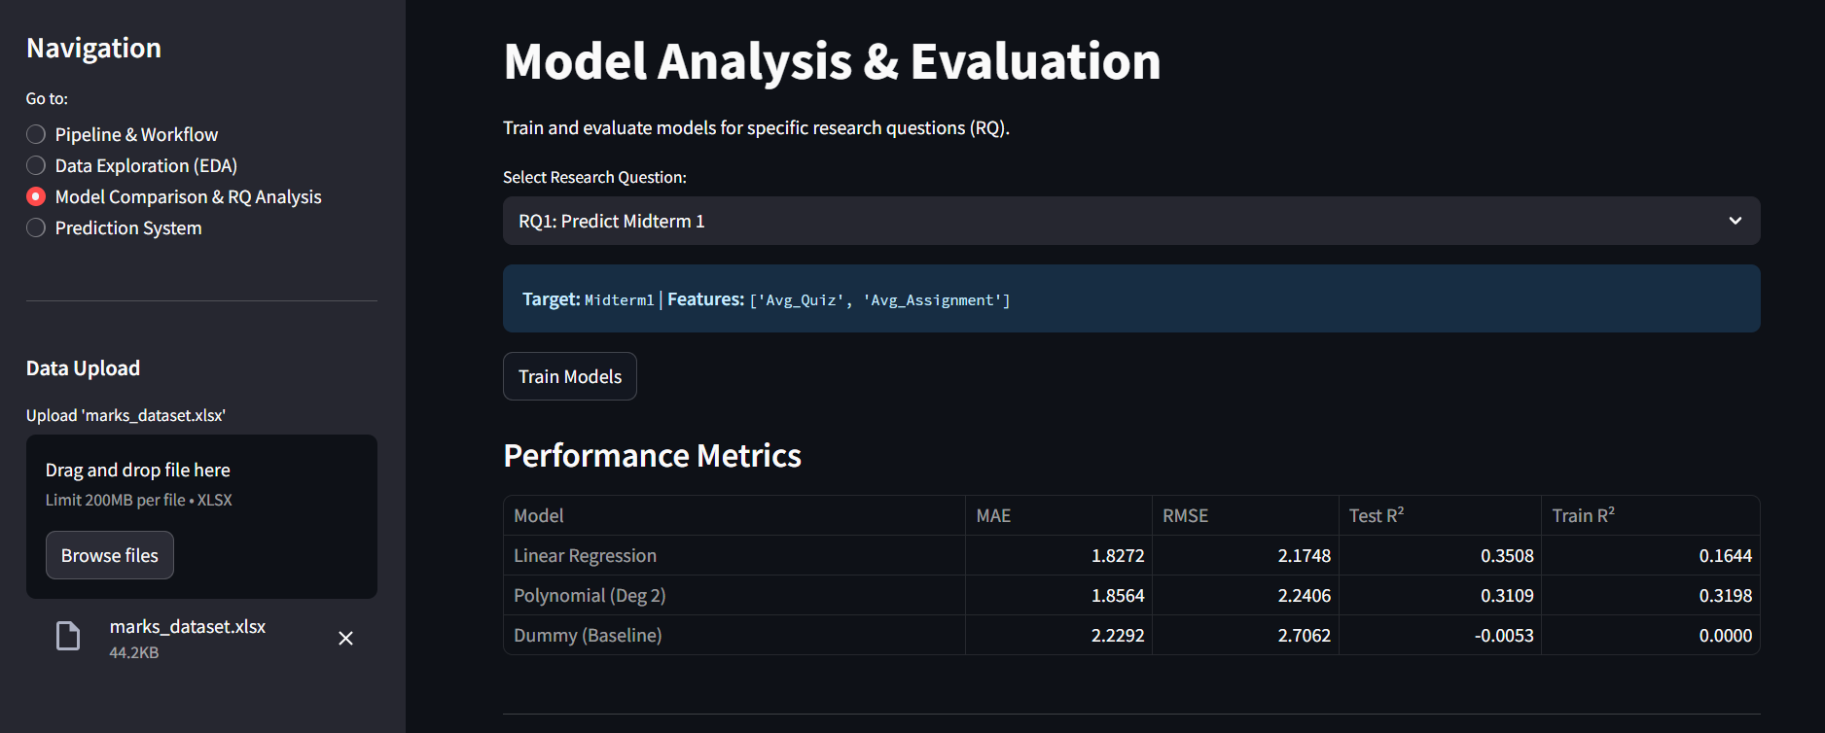
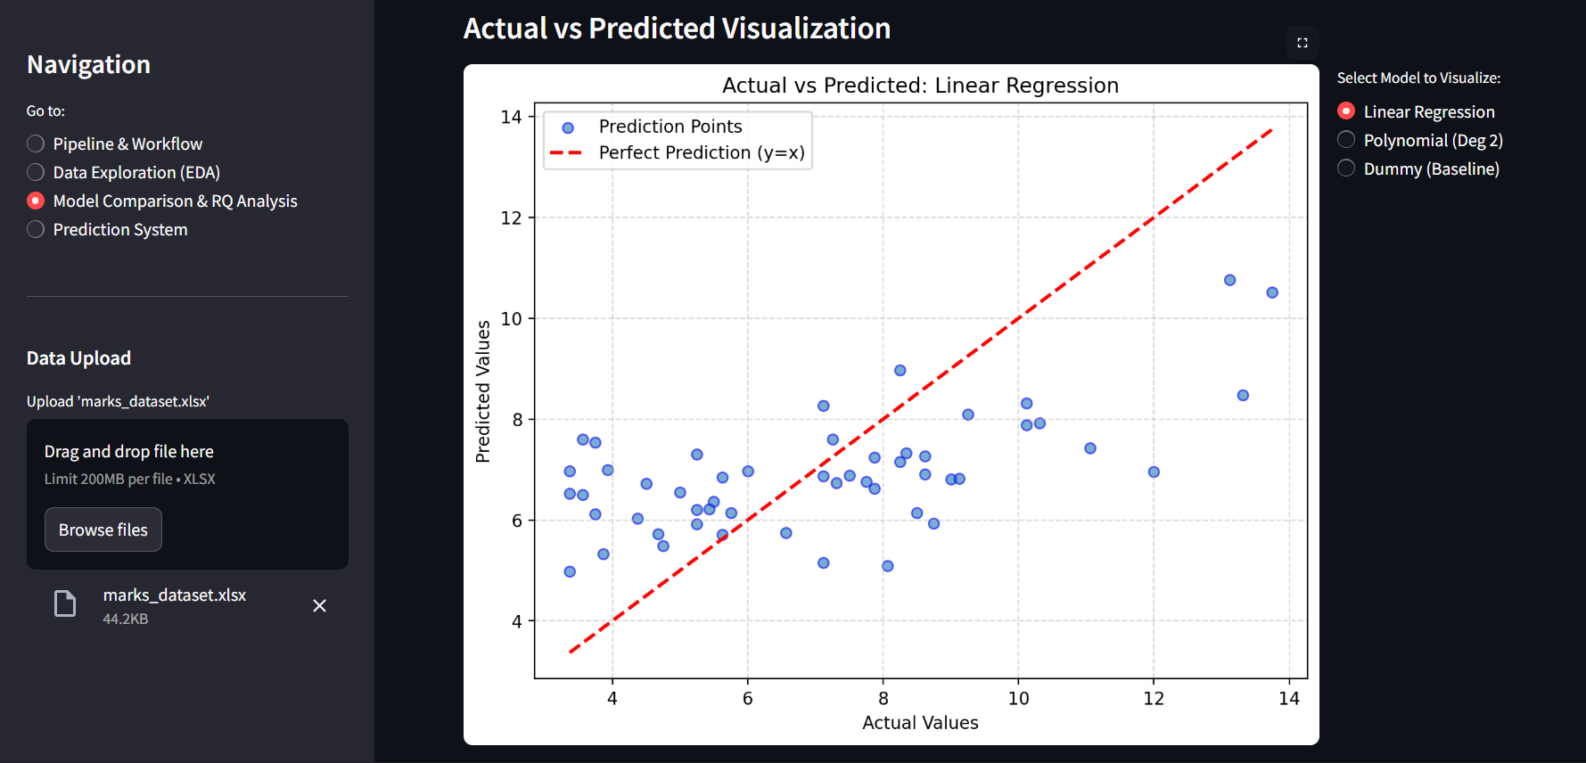
Same For RQ2 and RQ3

Fourth Page of the App:
Prediction System
